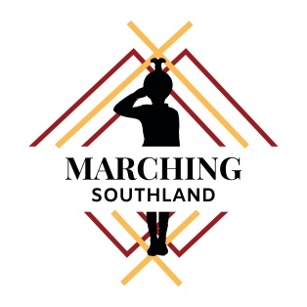

**Recommended Chaperon Kit**

*This is a list of things that are important to have in a Chaperon Kit.*

* A GO BOOK – List of emergency contact information, known allergies and regular medications
* Bobby pins (lots!)
* Hair gel/spray – Glitter
* brush/comb (at least 2 of each)
* spare pantyhose
* sanitary products
* first aid kit , Fabric band aids, paracetamol, Inhaler
* boot nugget
* Tissues & Wet wipes
* sewing kit, safety pins, uniform buttons
* sugar lollies
* elastic bands to hold gloves up (hair ties work too)
* hair ties
* spare boot laces
* spare over knickers
* lipstick (cotton tips so it can be applied individually)
* anything relating to display that will be needed (handy to put into the bag)
* leather hole punch for belts
* spare USB with display music
* spare whistle
* activity for younger teams to do while waiting off the field
* rubbish bag
* a bag to add a few essentials to take on field – (THIS MUST INCLUDE A 1ST AID KIT and Inhaler for Asthmatics )