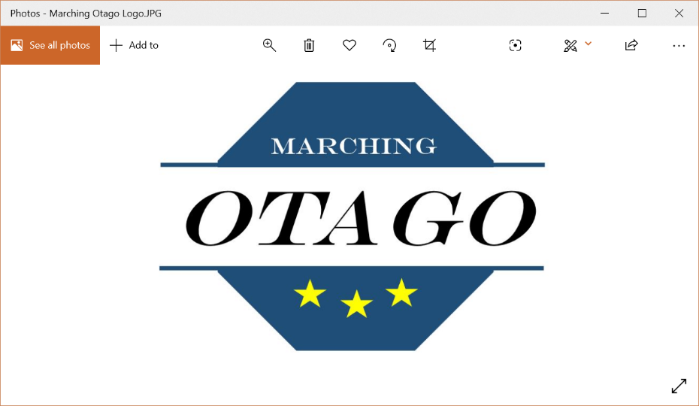

Competition Entry Form

# Contest Date:______________

# Team Name:­­­_______________________ Grade: ______________

## Phases: Technical/Display/Both

## Coaches: _______________________________________________________

## Chaperones: _____________________________________________________

## Manager: _________________________________________

## Marchers: **1. ______________________ 2. ______________________**

## **3. ______________________ 4. ______________________**

## **5. ______________________ 6. ______________________**

## **7. ______________________ 8. ______________________**

## **9. ______________________ 10. _____________________**

## **11. _____________________ 12. _____________________**

## **13. _____________________ 14. _____________________**

**Condition of entry:**

I certify that all persons whose names appear on this form are financial members of Marching New Zealand, and in the event of the above team winning any trophies, I hereby undertake to return in the same order and condition by the 31st August 2021.

**Coaches Name:**_______________________ **Address:** _________________________________

**Contact:** Home Phone: ________________ Cell Phone: ________________________

Work Phone: ________________ Email: ____________________________

### Association Details:

**Post Entries to:** Glenys Cowie (Marching Otago Secretary)

**Phone Number:** 03 4883114 or 021 1338739

**Postal Address:** 8a Alexander Street, Abbortsford, Dunedin 9018

**Email Entries to:** [otago@marching.co.nz](mailto:otago@marching.co.nz)

**Internet Banking:** Westpac: **03-0903-0437246-001** (please use team name as the reference)